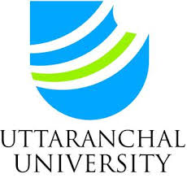 | UTTARANCHAL UNIVERSITY  Internal Quality Assurance Cell (IQAC)
 | Alumni Curriculum Feedback Form
Dear Alumnus/Alumna,
The department seeks your valuable feedback for enhancing the curriculum quality of the programme at Uttaranchal University.
Name and Registration No. |  | Year of Passing
Programme Name |  | Phone No. And Email ID
Details of the organisation currently associated |  | Designation

S. No. | The Descriptor | Strongly Agree  (5) | Agree (4) | Neutral (3) | Disagree (2) | Strongly disagree (1)
01 | The course curriculum was appropriate for career progression.
02 | Sufficient trainings, seminars, value added courses and PDPs were provided for holistic development.
03 | The programme involved experiential and participative learning.
04 | Research Work/ Project Work/Internships/Electives offered under programme were challenging and constructive.
05 | Proper industry-academia relationship was maintained across the programme.
06 | The curriculum offers courses with practical and hands-on learning experience.
07 | The curriculum was effective to build the opportunities in terms of employability, higher learning and entrepreneurial attitude.
08 | The programme enhances your ability to cope with a challenging situation and to work as a team.
09 | Relevance of course curriculum to real life situation.
10 | Curriculum is sufficient to develop presentation, report writing and technical skills.

Suggest any changes in course content for improvement or any new course introduced in terms of knowledge/skills, employability and entrepreneurship of students:

__________________________________________________________________________________
Suggestions regarding opening of a new program:

__________________________________________________________________________________
Relevance of curriculum in your job:
_________________________________________________________________________________

Signature of the Alumni

